OWASP HACKADEMIC PROJECT

INTRODUCTION:
The Hackademic Challenges implement realistic scenarios with known vulnerabilities in a safe, controllable environment. Users can attempt to discover and exploit these vulnerabilities in order to learn important concepts of information security through the attacker's perspective.
Currently, there are 10 web application security scenarios available.

TARGET GROUP:
Anyone can use the OWASP Hackademic Challenges to test one's knowledge and skills.
Nevertheless, the OWASP Hackademic Challenges have been mainly developed to be used in a live classroom environment. Experience has shown increased interest and engagement from students that actually get to practice application security and see how things work in a realistic environment.
The OWASP Hackademic Challenges can be easily deployed to any PHP-capable web server running mysql/mariadb.
Current deployments have integrated the OWASP Hackademic Challenges with well-known CMS software (e.g. Joomla) in order to provide a complete e-learning environment, where students can register and monitor their progress as they go through the challenges.

PURPOSE:
- The Hackademic Challenges is an open source project that can be used to test and improve one's knowledge of web application security.
- The Hackademic Challenges project implements realistic scenarios with known vulnerabilities in a safe, controllable environment. Users can attempt to discover and exploit these vulnerabilities in order to learn important concepts of information security through the attacker's perspective.
- They have been especially designed for use in a classroom environment where they have been proved a valuable educational tool. Using hackademic challenges students have the chance to experience application security in a realistic environment, something that triggers their interest and provokes a lot of interesting discussions.
- The Hackademic Challenges are currently used in several Universities and have received very positive feedback from both professors and students.

HACKADEMIC NEXT-DEV BRANCH:

This branch is aimed at making the Hackademic project more efficient and secure.
This branch has been developed for people to contribute and improve Hackadmeic CMS. The project team has focused on building upon this particular branch.

PURPOSE:

The main aim of the project is to create a sandbox environment so that the users can write a normal vulnerable web application as a challenge and leave it to hackademic to make sure that the server is not affected. Moreover the protected environments should run in such a way that it should not put excessive load on the servers.

Such a task includes running multiple instances of the protected environment such that it does not affect the performance of the server. Moreover running the vulnerable applications on the website should not cause harm to the server itself and any potentially dangerous attack should not be allowed to reach the server.

IMPLEMENTATION:

Creation of a protected environment obviously will include a virtualized environment that is separated from the original host. In this case the host will be the server and all the challenges will be contained in a virtual environment.

The virtual environment will be brought into effect with the help of the simple, yet sophisticated Linux Containers (LXC). The LXC will contain the same file system as a Linux machine and therefore has the ability to host the LAMP server. As soon as request for running a challenge is given, a container will be activated and the challenge will be redirected to the container thus hosting the challenge and running the vulnerable script inside the container. Moreover the challenge will be run in protected environment inside the container itself which can be attained by chrooting inside a separate root filesystem.

The challenge is redirected to the container with the help of port forwarding. The host will have an IP and the container application will run on a particular port. When a challenge is opened, the request is forwarded to the port where the container runs and the challenge will run in that particular container.

The containers are opened with the help of python scripts that run in the background. The python script automates the creation and the destruction of the containers as and when the challenges are opened and closed. This script also uses port forwarding that redirects the challenge to the containers. Many containers are opened depending on the number of users are attempting the challenges. As the traffic increases, the number of free containers will increase accordingly. Although opening so many containers maybe an overhead, idle containers are automatically swapped out relieving the RAM.

This sandboxed environment, even if compromised will give access only till the container's chrooted environment thus securing the server. The installation files will be included in the hackademic repository enabling the easy installation of container creating environment and the LXC filesystem.

For the creation of new containers copying the necessary files takes a lot of time and a majority of the files are the same. So a technique called union mount is used. With union mount different directories or filesystems can be combined and mounted onto a common mount point. The union mount also implements a copy-on-write system.

A master folder called rootfs has all the necessary files which are required to create a new container. The other containers have 2 folders inside them – write and mount. Using union mount the rootfs folder and the write folder are combined and mounted onto the mount folder. They are mounted with rootfs folder as read-only and write folder as read-write. So if any file is changed in the mount folder the changes only reflect in the write folder and not the rootfs folder. Thus we can create new containers without the overhead and the space requirements of copying files

ARCHITECTURE:

The system is implemented and maintained automatically using python scripts. It has 4 components

- Container.py – It is a class used to represent a container for the purpose of hosting a challenge

- ContainerDispatcher.py – It forms the core of the program. Its main purpose is to create new containers whenever a request is received. It maintains a list of containers installed, starts the whenever necessary and uses Forwarder.py to port forward a local port to port 80 of that container

- Forwarder.py – It is used to implement port forwarding in the system

- ChallengeLoader.py – it acts as a server listening to requests for new containers. When a request is received from the check.php it calls ContainerDispatcher.py retrieve a free container. ChallengeLoader.py then finds out the appropriate local port that is mapped to the supplied container and sends it to check.php.

- Check.php – Whenever the ‘try challenge’ button is clicked for a challenge the user is redirected to the check.php page. This frame has an iframe component which acts as a window to the sandboxed environment. When the page is first loaded it sends a request to ChallengeLoader.py for a new container. It then gets a port number for a free container. The challenge request URL is then modified accordingly with the received port number loaded into the iframe. So the iframe will load the challenge within the container.
INSTALLATION – CENTOS6
To take the security for your host machine up a notch, you can go ahead and install a virtual machine in the system that will run the actual server i.e the virtual server. It may slow down the host a little bit, but decrease in speed can be compensated by an increase in security.
Virt-manager can be installed for the guest server, that supports hypervisors like Qemu. The guest operating system can be, preferably centOS. The following steps can guide you through the process of OS installation in virt-manager.

- Open the terminal and type the following command to install virtual machine manager: sudo apt-get install virt-manager

- Open Virtual Machine Manager and start a new machine.

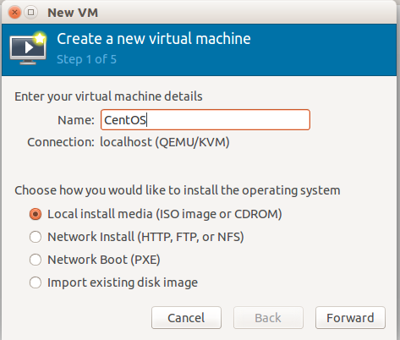

- Select the required iso image for the OS to be installed.
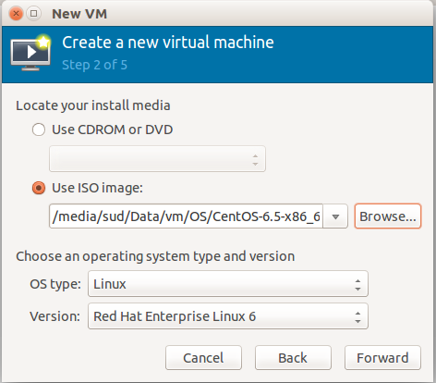

- Enter the RAM required by the guest OS and the number of CPUs that will be used when qemu is running. It is generally advisable to give less than half the RAM and half the number of CPUs.

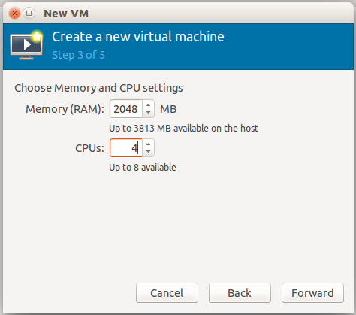

- Next step will involve the storage volume to be selected where the OS needs to be installed. If a storage volume does not already exist, which is the default case, then a new volume has to be created. The 'Select managed or other existing storage' option will help in creating a new volume.

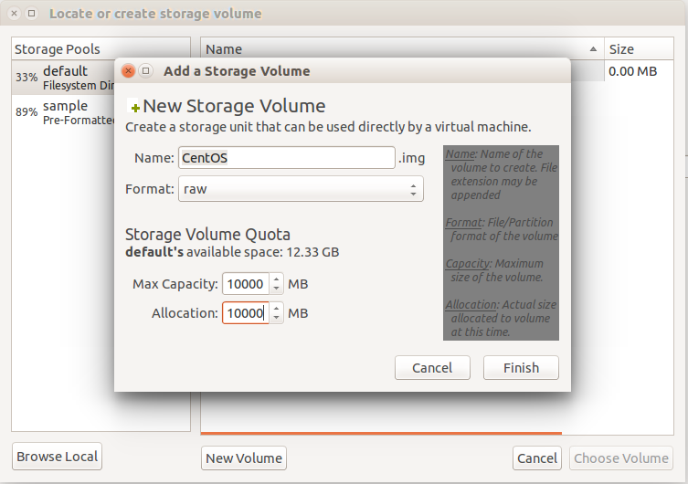
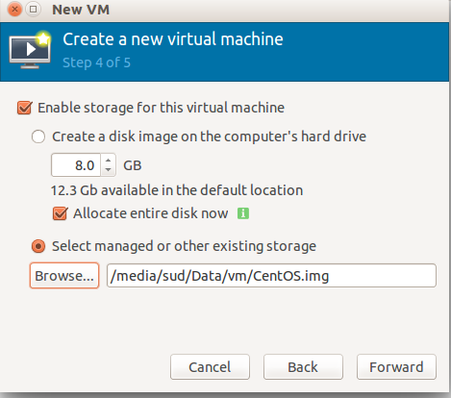
- Select the newly created .img volume for the installation.

- In this step, under advanced options, change “Virtual network 'default': NAT” to “Virtual network 'duplicate':NAT” which will enable the duplicate network to operate on an IP different from the host's IP.

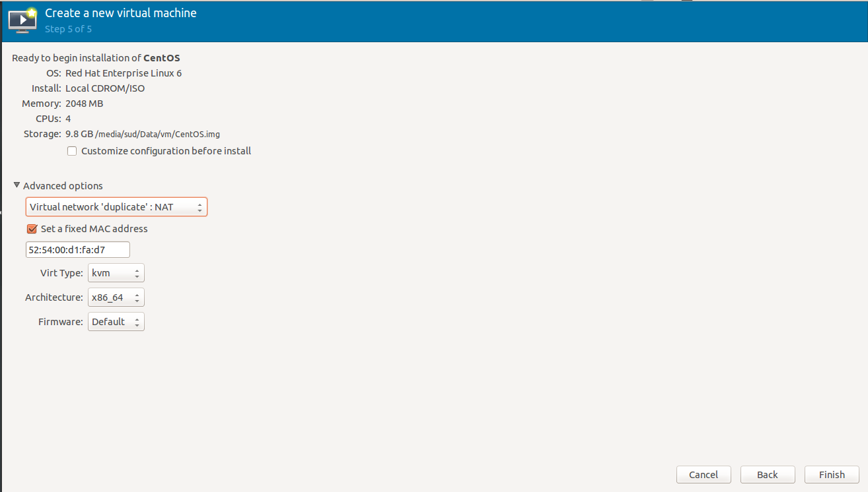

- Before starting the machine, go to Edit → Connection details → Virtual Networks. Deactivate the default network and activate the duplicate network.
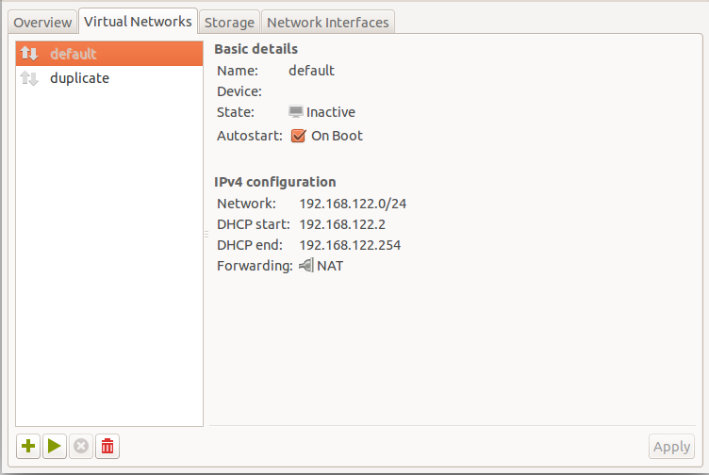
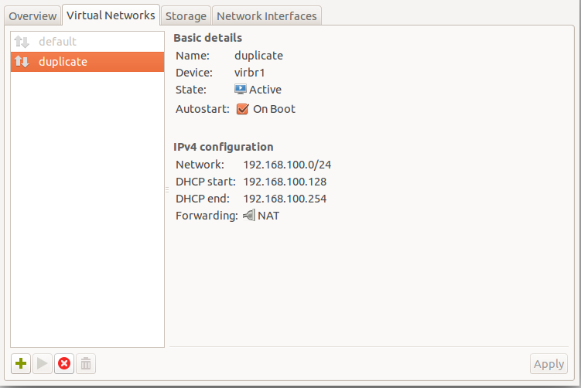
After the installation of CentOS in the guest machine, go through the following steps :

- Install LAMP in guest machine, if not already installed. LAMP consists of Apache2/httpd ( depending on the OS ), Mysql, and phpmyadmin. Installing and setting these up appropriately, will get you ready to start a full fledged server. The following Youtube link can be of help: https://www.youtube.com/watch?v=d77RoSuL44I

- Deploying Hackademic is the next task. Clone the next-dev branch of the Github repository in the /var/www/html directory and it will be ready to serve any request coming for hackedemic to your server and follow the README file for the next steps. The github link of the repository: https://github.com/Hackademic/hackademic.git

